Human-edible Acacia s.l. products, overlooked treasures in the arid tropics – A commentary
Moustapha Soungalo Drabo^{1,2}*, Aly Savadogo & Katleen Raes
1. Research Unit VEG-i-TEC, Faculty of Bioscience Engineering, Ghent University, Sint Martens Latemlaan 2B, 8500 Kortrijk, Belgium
2. Laboratoire de Biochimie et Immunologie Appliquées, Unité de formation en Science de la Vie et de la Terre, Université Joseph Ki-Zerbo, BP 7021 Ouagadougou 03, Burkina Faso
* moustaphasoungalodrabo@ugent.be
Short abstract
Acacia s.l. is a newly revised genus, whose plant (~1500) species are quintessential in the pantropical, arid, and the most hunger-prone areas worldwide, including Aridoamerica, Outback Australia, southern Asia, and Subsaharan Africa. However, the ecological roles of Acacia s.l. plants are still underestimated. Particularly, their ability to provide a food safety net and empower millions of indigents in their native areas has been overlooked for a very long time. The research on them has drawn interest only recently after the revision of their nomenclature at the XVII International Botanical Congress in Vienna in 2005. A comprehensive literature review has allowed us to identify a couple of trending human-edible products, including gums or resins, honeys and seeds (promising protein alternatives), from acacias. Besides, Acacia shoots (e.g., Acacia pennata shoots or cha-om), though lesser known, have also appeared as promising healthy vegetables for humans, highlighting the food and medicine continuum of Acacia edible products. The dissemination of the food products from acacias and their nutritional benefits can help underpin better environmental stewardship in the arid tropics. This communication highlights the different research fronts (i.e., nutrition, technology, environment, and ethnoecology) for human-edible acacia products, hoping to stimulate a concerted research incentive.
Keywords: Acacia, arid tropics, food, environmental stewardship, hunger

Extended abstract
Acacia plants thrive in the arid tropics (Fig. 1A), where they constitute the backbone of the vegetation and support human livelihood. They provide food, medicine, and income to the indigenous people. However, Acacia s.l. have been for a long time an unresolved polyphyletic genus. It is only recently that their classification has been revised, recognizing seven monophyletic segregates, i.e., Acacia sensu stricto (1082 species), Acaciella (15 species), Mariosousa (13 species), Senegalia (220 species), Parasenegalia (11 species), Pseudosenegalia (2 species), and Vachellia (164 species). Besides, the reclassification of the Acacia s.l. led to the revision of the nomenclature, which raised a deep controversy between Australian Acacia researchers and Africa, America, and Asia native Acacia researchers [1]. The revised nomenclature resulted in the conservation of Acacia s.s. for Austroacacias and the transfer of Africa, America, and Asia native Acacia s.l. to Acaciella, Mariosousa, Senegalia, Parasenegalia, Pseudosenegalia, and Vachellia genera. Interestingly, the controversy over the revision of the nomenclature has stimulated the research on Acacia s.l., resulting in the identification of 141 new species, including 106 Acacia s.s., 24 Senegalia, 3 Parasenegalia, 1 Pseudosenegalia, 1 Acaciella, and 1 Mariosousa species between 2006 and 2021 (Fig. 1B).
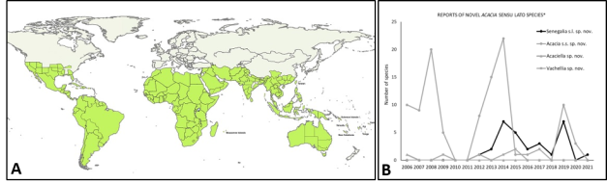
Fig. 1. Distribution of Acacia sensu lat. globally (A) and recently identified species (B)*
The map and the number of new species have been retrieved from http://worldwidewattle.com/speciesgallery/search.php using (accessed 20/10/2022). *The graph is adapted from [1].

More interestingly, the regained interest in acacias has also apparently attracted attention to their ecological roles and benefits for humans (i.e., ethnobotany) (Fig. 2). This communication focuses on their edible products for humans, which have been overlooked for a very long time, despite their historical contributions to human survival and civilization in the past [1,2]. Human-edible Acacia products have also received some attention since 2006 (Fig. 2A), after the revision of their nomenclature at the XVII International Botanical Congress in Vienna in 2005. The current research on human-edible Acacia products is more focused on the environmental benefits of the plants in agroforestry and the chemistry and pharmacology of the plant products (Fig. 2B). The resin, mostly known as acacia gum, the honey from Acacia flower, and the seeds received more attention for their food potential (Fig. 2C).
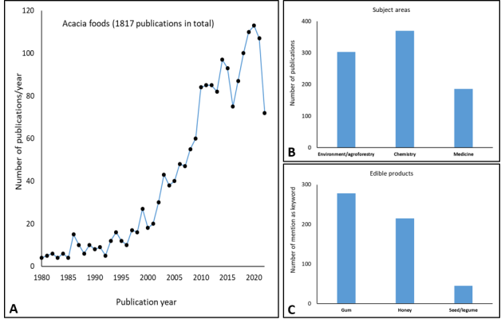
Fig. 2. Trend in Acacia food research (A), research subject areas (B), and rising products (C)*
*Scopus was consulted (20/10/2022) using the keywords “Acacia” and “food”, the Boolean operator AND, and the search fields “title”, “abstract” and “keywords”. *Besides, Acacia shoots (e.g, Acacia pennata shoots or cha-om), though lesser known, have also appeared as promising healthy vegetables for humans [1].
Considering climate change and the worsening of global food insecurity, it is more than ever essential to safeguard and underpin better environmental stewardship, which has been essential to people resilience in the past. A tremendous effort is still needed to inventory and disseminate knowledge on human-edible products from acacias, quintessential but still understudied natural resources in the arid tropics. This communication has carefully selected key ongoing works [1–4] to comment on, and highlight the food potential of Human-edible Acacia s.l. products, and hopefully stimulate more interest and concerted research (at the nutrition, technology, environment, and ethnoecology fronts).
Conflict of interest
The authors declare no conflict of interest.
References
1. Flann C, Mcneill J, Barrie FR, Nicolson DH, Hawksworth DL, Turland NJ, et al. Report on botanical nomenclature — Vienna 2005. XVII international botanical congress, Vienna: nomenclature section, 12–16 July 2005. PhytoKeys. 2015;45:1–341.
2. Drabo MS, Shumoy H, Savadogo A, Raes K. Inventory of human-edible products from native Acacia sensu lato in Africa, America, and Asia: Spotlight on Senegalia seeds, overlooked wild legumes in the arid tropics. Food Res Int [Internet]. 2022;159:111596. Available from: https://doi.org/10.1016/j.foodres.2022.111596
3. Curran G, Barwick L, Turpin M, Walsh F, Laughren M. Central Australian aboriginal songs and biocultural knowledge: Evidence from women’s ceremonies relating to edible seeds. J Ethnobiol. 2019;39(3):354–70.
4. Kalilou O. Climate change and conflict in the Sahel: The acacia gum tree as a tool for environmental peacebuilding. Int Aff. 2021;97(1):201–18.
5. Adiamo OQ, Netzel ME, Hoffman LC. Acacia seed proteins : Low or high quality ? A comprehensive review. Compr Rev food Sci Food Saf. 2019;1–23.
6. Francis R. Wattle We Eat for Dinner. In: Francis R, editor. Proceedings of the Wattle We Eat for Dinner Workshop on Australian Acacias for Food Security. World Vision Australia & AusAID; 2011. p. 1–146.

