Title of your abstract (Times New Roman 14pt, bold)

Author 1 ª, Author 2 ^{b}, Author 3 ^{c}, Author 4 ª, Author 5 ^{c} (Times New Roman 12pt )
(underlined author = presenting author)
ª Institute 1, City, Postal code, Country (Times New Roman 10pt, Italic)
^{b} Institute 2, City, Postal code, Country
^{c} Institute 3, City, Postal code, Country
e-mail: xxx@xxx.xx.xx (Times New Roman 11pt, Italic)

Abstract Text (Times New Roman 12pt, single spacing)

Each abstract must state clearly:
- The purpose of the work.
- The manner and degree to which it advances the state of the art (novelty, originality).
- Specific results that have been obtained.

Authors are asked to submit a one-page abstract in one-column format. In the page setup the paper size should be set to A4.

If included in the abstract, a figure or a photo should have a short caption directly underneath with a concise explanation of them.
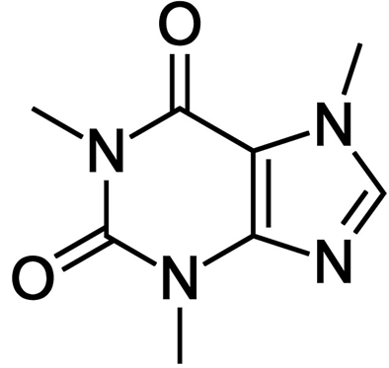
Figure 1: The chemical structure of the caffeine molecule
(Times New Roman 11pt, single spacing)

References: The reference list should be written as in the examples given hereafter for articles in journals [1], books [2], papers in a contributed volume [3], and thesis or unpublished work [4].
(Times New Roman 10pt, single spacing)
- Qualtieri, F. Pisanello, M. Grande, T. Stomeo, L. Martiradonna, G. Epifani, A. Fiore, A. Passaseo, M. De Vittorio, Microelec. Eng. 84 (2010) 1435-1438.
- E. Borger, Computability, Complexity, Logic (North-Holland, Amsterdam, 1989).
- A.K. Lenstra and H.W. Lenstra, Jr., Algorithms in number theory, in: J. van Leeuwen, ed., Handbook of Computer Science, Vol. A (Elsevier, Amsterdam, 1990) 673-715.
- A. Rajasekar, Semantics for logic programs, Ph.D. Thesis, Department of Computer Science, University of Maryland, 1989.

IMPORTANT DETAILS:
- Abstracts will be accepted ONLY in English.
- Abstracts should be sent in both Word Document Format (.docx) and Portable Document Format (.pdf).
- The submitted abstracts should be titled as: Presenter name-oral or poster.docx (e.g. Maria-Papadopoulou-poster.docx)
- Abstracts should be submitted on-line via e-mail: Grad-symp@chem.uoa.gr.
- After the submission deadline NO Abstract will be accepted!
- Please KEEP the format of the template!

